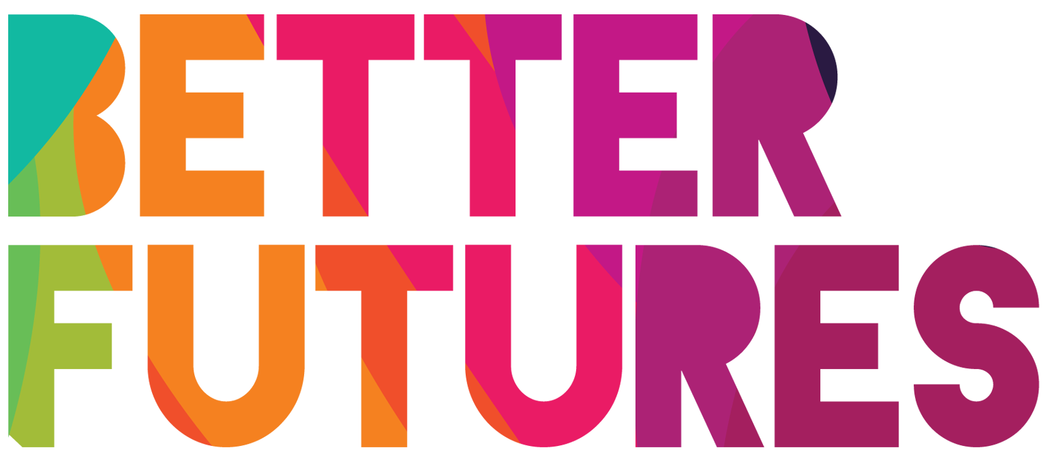 | 🌠INSPIRE ▶️ link to full series

First, watch the video 🔻  🎯 Goals of this activity: | My Activity  Why and how will my business help people?  ⏳ This activity is split into 4 parts. Part 1 will take 30 minutes;  part 2&3 2 hours; and parts 4 around 3 hours.  💬🗨️ Format: This activity can be done in different ways:  - With a mentor, coach or a friend  ⭐recommended  - On your own  - In a group: each of you do it & share & give feedback

- For you to understand that entrepreneurs are also customers of products and services  - For you to think about what problem you want to solve and how your solution can help others | - For you to define the type of customer that will benefit from your business  - For you to ask and receive constructive feedback from your potential customers that will improve your solution

⁉️ How to do the activity (✅ tick the checkboxes when you have completed each step)
- 1️⃣ Decide whether you want to do this activity on your own, with 1-1 support or in a group.  - 2️⃣ Watch the video for this activity.  - 3️⃣ Think for a moment: What did Amr do  to make a difference in the life of his customers?  - 4️⃣ Part 1 will help you see yourself as a customer. You will think about what product / service you use the most and understand how it helps you. This will help you understand how your customers think.  - 5️⃣ Part 2 & 3 will help you identify what problem you want to solve and who you want to help. | - 6️⃣ In part 4, you will contact your potential customers! Ask them questions about their problems and needs and how your product or service could benefit them.  - 7️⃣ After the meeting, reflect again about  parts 2 and 3 of the activity and update  your statements based on your customer feedback.  - 8️⃣ Finally, watch the video “Understanding Customers Trends” to learn more about customer needs and trends.

1 We are all customers 🛒 ! What products & services do YOU use?🛍️
What services do you use daily / every week? 🚌 | Which of those is your  favourite service? 🏆 | How does this service  help you with your life? 💪 | What do you like  about this service? 🤩
1...✍️  2.  3. | My favourite service is  …✍️ | This service helps me because...✍️ | I like using this service because…✍️
Which products  do you use every  day or every week? 👖 | Which of those is your  favourite product? 🏆 | How does this product  help you with your life? 💪 | What do you like  about this product? 🤩
1...✍️  2.  3. | My favourite product is…✍️ | This product helps me because…✍️ | I like using this product because...✍️

2 Now, 💭 think as an entrepreneur:
What problem for people or planet are you going to solve?
What important problems do people or the planet around you have🧐? |  | Do I want to solve this problem? 🛠️
1.Problem 1 is…✍️ |  |  | ☐ Yes ☐ No
2. Problem 2 is…✍️ |  |  | ☐ Yes ☐ No
3. Problem 3 is…✍️ |  |  | ☒ Yes ☐ No |  | ☐ Yes ☐ No
What product or service can you create to help solve the selected problem(s) 🏗️ | My solution to fix this problem is…✍️
How would your  product / service  help your customers? 💡 | My product/service is helping my customers because…✍️

3. Who can you help with your solution?💆
Who would be interested in using your product/service? 🙋‍♂️ | The people who would be interested in my product/service are…
Great! The people who are interested in your product/service are your customers! 🙋‍♂️
Let’s go a bit more in detail. 🔎 Imagine and describe a person who would benefit from your solution 🏗️
Personal information  •Name:  •Age:  •Location:  •Hobby:  •Occupation: | How can your product or service help this person?  ...✍️ | Why does this person use your product or service instead of an existing solution?  ...✍️ |  | What do they like the most in your product or service?  ...✍️

4.🙋‍♂️ Meet and understand the people you can help 🙋‍♀️ Contact your customers!
Who are the real people around you who need your product or service and who could be your customers? 🛠️ | The people around me that would be interested to use my solution are…✍️
📅 How will you  make contact  with these people? ☎️ | I will contact them by…✍️
What 💬 feedback & ideas have you received from talking to these people? | From talking to my potential customers, I have learned that…✍️
What did they find helpful 🎯 about your product / service? | What they find helpful about my product/service is…✍️
What did they like 👍? |  |  | What did they dislike? 👎
They liked:  - …✍️  - …✍️  - ...✍️ |  |  | They disliked:  - …✍️  - …✍️  - …✍️
🤩 Improve your product or service based on the feedback received from your customers 💬 | Based on the customer feedback, I can improve my solution by…✍️
