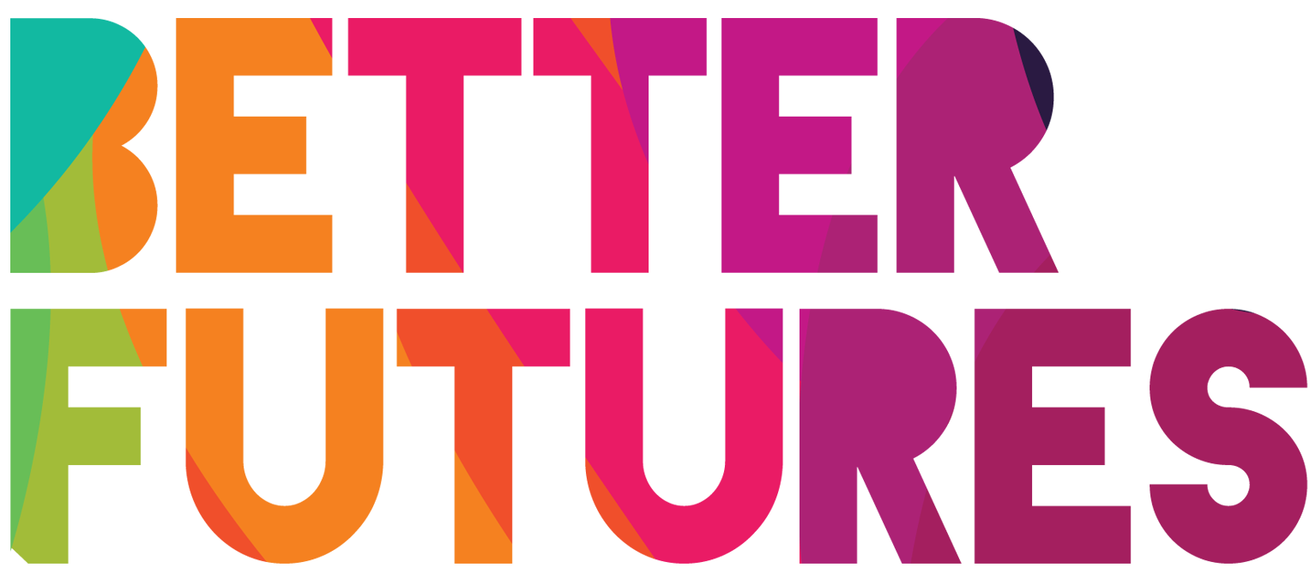 | 🌠INSPIRE ▶️ link to full series

First, watch the video 🔻  🎯 Goals of this activity: | My Activity  My skills & training plan  ⏳ This activity will take you around 2 hours  💬🗨️ Format: This activity can be done in different ways:  - With a mentor, coach or a friend ⭐recommended  - On your own

For you to think what would excite you about becoming an entrepreneur  For you to think what your alternative career pathways are aside from entrepreneurship | For you to compare entrepreneurship  against those other career pathways  For you to start working on a choice of  career pathway that fits your needs & desires

⁉️ How to do the activity (✅tick the checkboxes when you have completed each step)
- 1️⃣ Decide if you want to do this activity on your own or with 1-1 support from a mentor or coach.  - 2️⃣ Watch the video for this activity  - 3️⃣ Think for a moment:  What skills does Maria recommend in the video  as essential to the success of an entrepreneur?  - 4️⃣Read the information in part 1 to understand what types of skills & mindset traits you need to become an entrepreneur | - 5️⃣Now think about the kind of business you want to start (ideally discuss this with a mentor). What technical skills and business skills, as well as what kind of mindset traits would you need to successfully set up and run such a business? Fill in the types of skills you need in part 2.  - 6️⃣ Next, work with your mentor or with a career’s advisor in your city to identify real world organisations in your city, as well as online courses, where you can develop the relevant skills.  - Once you are done planning, get started by choosing the course(s) and training that are the biggest priority right now.  - Find out the admission criteria and whether there is an option to get this training free of charge (for example through a scholarship)  - Apply for the courses that fit your needs and that you can afford.

1 What types of 🎓 Skills are there & where to learn them.
Learning  Categories | What you need to learn concretely:  Use these search terms to find  relevant learning opportunities | Where can you learn this?
Technical skills  I need to learn | Technical skills enable you to…  …make products …deliver services  …work online …communicate in modern ways  …design brands and marketing  …communicate professionally  Why are they useful?  People with mastery of a technical skill, especially if they have a formal qualification, are often in high demand for jobs. Also, they have a skill that is so strong that they might be able to start a self-employed activity / start a business around it. | You can learn technical skills in…  - Vocational skills colleges  - Internships  - Apprenticeships  - On the job  - By doing online courses and  then trying things out yourself
Business skills  I need to learn | Business skills enable you to…  …make informed business decisions  …create a profitable business model  …spot opportunities …set up a business  …plan financially …hire and manage employees  Why are they useful?  It is great if you have technical skills (see above) but you still need to manage the customer facing, legal and financial side of the business. Also, you may not be running the business on your own and may have to employ other people. Business skills are important to manage all of these things well. | You can learn business skills in…  - Startup programmes  - Business training programmes  - Online business courses  - Internships with businesses  - University education  - Working experience at a management level
I need an Entrepreneur’s  Mindset | Mindset & Management skills enable you to…  …stay motivated …plan for the future.  …communicate with others … work with others  Why are they useful?  The right mindset is important to anyone who wants to have a successful career. A good mindset is even more important for entrepreneurs than for employees – if the entrepreneur has all the technical & business skills needed but does not have the right attitude it is very hard to run a successful business and stay motivated through the ups and downs of starting and running a company. | You can learn mindset & management skills…  - By getting a mentor  - By getting a coach  - By attending to mindset building & motivational courses  - Through life & work experience  - By reading books about entrepreneurial mindset  - By watching inspirational  speakers online  - By reading autobiographies of entrepreneurs whom you respect

2 My Learning Plan 🎓
Learning  Categories | Decide what you want to learn  Use these search terms to find relevant learning opportunities | Where will you learn this?  Do an internet search to find online training courses and real world places where you could learn this skill in person
Technical skills  I need to learn | 1st Technical skill: ✍️
 | 2nd Technical skill: ✍️
Business skills  I need to learn | 1st Business skill: ✍️
 | 2nd Business skill: ✍️
Entrepreneur Mindset traits  I need to learn | 1st Mindset trait I need to learn: ✍️
 | 2nd Mindset trait I need to learn: ✍️
Work Experience  I need to get | 1st type of work experience: ✍️
 | 2nd type of work experience: ✍️

