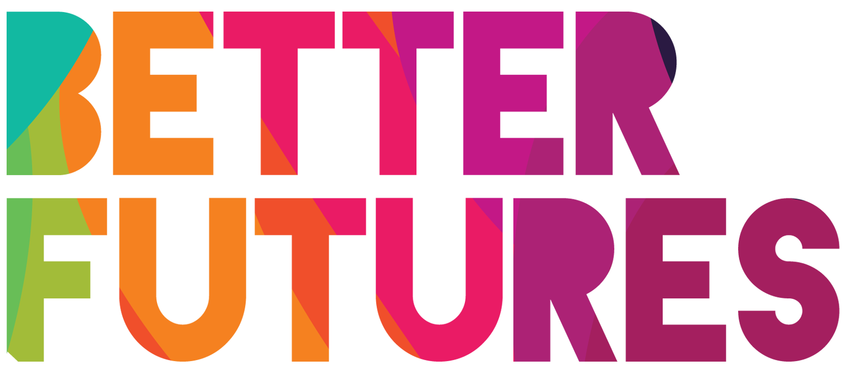 | 🌠INSPIRE ▶️ link to full series

First, watch the video 🔻  🎯 Goals of this activity: | My Activity  Get Inspired by amazing creative businesses  from around the world  ⏳ This activity is divided into 3 parts.  It will take around 2 hours for parts 1,  2 hours for part 2 and finally 2 hours for parts 3,  💬🗨️ Format: This activity can be done in different ways:  - On your own ⭐recommended

You will consider how you could use your creativity to start a business  You will identify what creative field  you want to become active in | You will make a plan to learn from other creatives  You will outline the first steps in setting up and running your own creative business

⁉️ How to do the activity
(✅tick the checkboxes once you have completed each step)
- 1️⃣Take the time to do this task on your own and at your own speed  - 2️⃣ First, watch the video for this activity  - 3️⃣ Think for a moment: What motivated Fatma to become creative?  - 4️⃣Now it is time to think about what motivates you to start a creative business! Complete activity 1 in the template below. | 5️⃣Next, do a bit of internet research to find other creative businesses to inspire you and get new ideas. Take notes in part 2 of the template.  - 6️⃣ After this, take some time to think about what you have learned from Fatma and the other businesses that you found online.  - 7️⃣ Finally, work on activities 3 to outline your own creative business idea.  - 8️⃣ Once you have defined your business idea, move on to the “GET STARTED” series & activities here.

1 My Creativity
What creative skills are you very good at? | Visual creative skills |  | Technical creative skills |  | Storytelling skill
 | ☐ | Drawing | ☐ | Digital design | ☐ | Presenting on camera
 | ☐ | Painting | ☐ | Graphic Design | ☐ | Public speaking
 | ☐ | Photography | ☐ | Photo editing | ☐ | Telling stories
 | ☐ | Sculpturing | ☐ | 3D modelling & design | ☐ | Radio presenting
 | ☐ | Crafting | ☐ | Marketing design | ☐ | Acting
 | ☐ | Crafting | ☐ | Print design | ☐ | Presenting on camera
 | Music creative skills |  | Video and film skill
 | ☐ | Singing | ☐ | Filming / camera work
 | ☐ | Playing instruments | ☐ | Editing
 | ☐ | Writing lyrics / songs | ☐ | Directing
 | ☐ | Composing | ☐ | Set design
 | ☐ | Live performing | ☐ | Lighting
 | ☐ | Recording & editing | ☐ | Script writing
Which of the above skills  are you best at?  This could be the skill that you could  start with & offer to customers |  |  | My Strongest skill is: ✍️
In what moment in your life  did you feel most creative? |  |  | My most creative moment was…✍️  In that moment I felt…✍️
What do you enjoy  about being creative? |  |  | ✍️
What motivates you  to start a creative business? |  |  | ✍️

2 Learning & getting inspired by other creative businesses
In your life, who is the creative person who inspired you the most?  How did this  person inspire you?  What do they do better  than anyone else? | ✍️
Go to these Sources to find more creative businesses to get ideas and inspiration | 1. Open Instagram on your phone  2. Search for #hashtags like “#photographybusinesses”  or “#musicbusinesses”  3. Check out the Instagram accounts of these businesses & do the activity below | 1. Visit www.pinterest.com  2. Search for creative businesses that match your strongest skills, for example “photography businesses” or “music businesses”  3. Find the Instagram accounts of these businesses & do the activity below
Names of the  creative businesses  that I found and liked: | What I 👍 liked about these businesses | What customers say about them
✍️ ... | I liked…  👍 ...  👍 ...  👍 ...
✍️ ... | I liked…  👍 ...  👍 ...  👍 ...
✍️ ... | I liked…  👍 ...  👍 ...  👍 ...

4 My Creative Business Idea
Describe the services your business  will offer to customers: | ✍️
To run my business,  I will use  the following  creative skills: | ✍️
Here is how my service / product would be useful to customers: | ✍️

