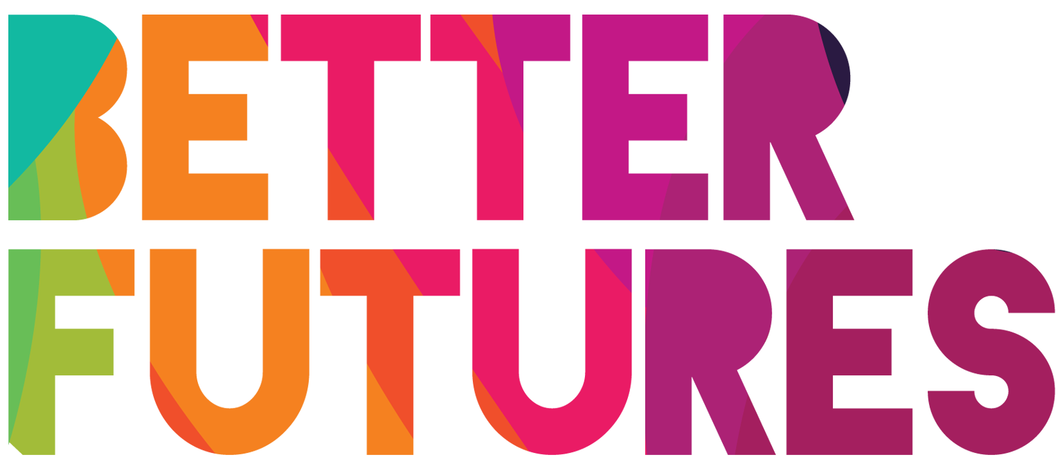 | 🌠INSPIRE ▶️ link to full series

First, watch the video 🔻  🎯 Goals of this activity: | My Activity  Why entrepreneurship?  ⏳ This activity will take around 1 hour for parts 1-3  & around 4 h for parts 4-6  💬🗨️ Format: This activity can be done in different ways:  - With a mentor, coach or a friend  ⭐recommended  - On your own  - In a group: each of you do it & share & give feedback

For you to think what would excite you  about becoming an entrepreneur  For you to think what your alternative career pathways are aside from entrepreneurship | For you to compare entrepreneurship  against those other career pathways  For you to start working on a choice of  career pathway that fits your needs & desires

⁉️ How to do the activity (✅tick the checkboxes when you have completed each step)
- 1️⃣ Decide whether you want to do this activity on your own, with 1-1 support or in a group.  - 2️⃣ Watch the video for this activity  - 3️⃣ Think for a moment: What motivated  Fatma to take the path of entrepreneurship?  - 4️⃣Read & think through and fill each part  of the the activity template below  - 5️⃣Once you have completed parts 1 to 3 of the activity, think about who in your network has real experience as an entrepreneur. This could be one person or several people. Decide who to contact. | - 6️⃣ Contact the people you have identified - tell them that you are thinking about becoming an entrepreneur and that you would find it very valuable to hear about their experience - to help you understand life as an entrepreneur better, and what it takes to get started. Meet with them online or in person.  - 7️⃣ After the meeting, reflect again about parts 1-3 of the activity and update your statements if your opinion has changed.  - 8️⃣ Finally, work on activities 5 and 6.  By the time you complete these, you should have  a better understanding as to why, when and  how you could start becoming an entrepreneur. 👍🏽🎯

1 ❓💖Why Entrepreneurship?
What about entrepreneurship  🤗🥳🤩 excites you? | ✍️
How would you ☘️benefit from  being an entrepreneur? | ✍️
How would becoming an  entrepreneur make you 🌱grow? | ✍️
2 Right now in your life, what would be the advantages
and disadvantages of taking the next step to:
...become  an entrepreneur | …get  a full-time job | ...studying
The 👍🏽advantages | The 👍🏽advantages | The 👍🏽advantages
👎🏽 disadvantages | 👎🏽 disadvantages | 👎🏽 disadvantages
4 Who in your network  will you💬🗨️ talk to,  to learn more about what life as an entrepreneur is like? | ✍️
5 📅 When would  be the right time  for you to become an entrepreneur? | ✍️
6 What do you still need  to 🎓 learn before you  become an entrepreneur? | ✍️
