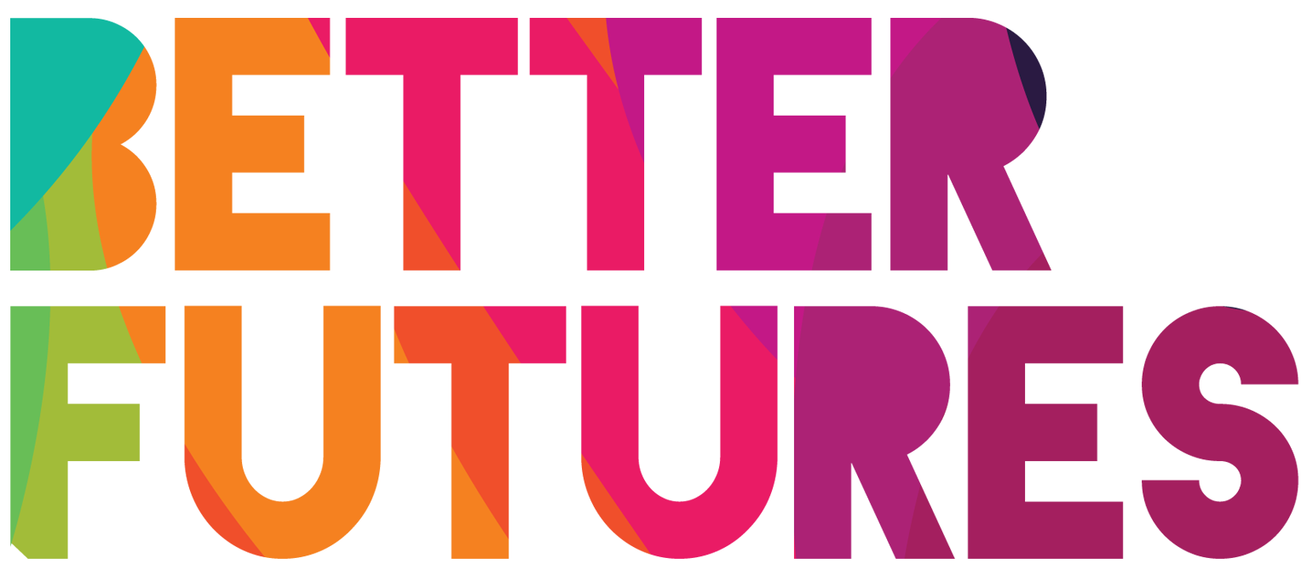 | 🌠INSPIRE▶️ link to full series

First, watch the video 🔻  🎯 Goals of this activity: | My Activity  Planning my food business  ⏳ This activity will take around 2 hours for part 1, 30 minutes for part 2, and around 4 h for parts 3 to 5.  💬🗨️ Format: This activity can be done in different ways:  - With a mentor, coach or a friend ⭐recommended  - On your own  - In a group: each of you do it & share & give feedback

For you to define what is your food market  For you to identify which type of food business you want to build  For you to describe the type of customer that you want to reach | For you to determine who are your competitors  For you to clarify the brand and story behind your food  For you to discuss your idea with other professionals and build partnerships.

⁉️ How to do the activity (✅tick the checkboxes when you have completed each step)
- ☐ Decide whether you want to do this activity on your own, with 1-1 support or in a group.  - ☐ Watch the video for this activity  - ☐ think for a moment: What useful tips Fatma shared in the video to start your own food business?  - ☐ Read & think through and fill each part  of the activity template below  - ☐ Once you have completed parts 1 - 2 of the activity, conduct some research on other food businesses | - ☐ Once you have researched and observed other food businesses, complete parts 3  - ☐ After this, take some time to reflect on how part 4 can inspire what you want people to see your food business as a brand and how you will communicate with your customers.  - ☐ Finally, work on activity 5 to discuss your food business with potential partners. What win-win situation can you create?

1 First, define your food market 🍔
What makes you  passionate 🤩 about food? | I am passionate about food because…✍️
How would you describe your type of cuisine? 🥙 | I would describe my cuisine as…✍️
What is your 🌟🍳  best dish? | My best / my signature dish is…✍️
What is the story 🍿  behind your signature dish? | The story behind my signature dish is…✍️
🍽️ What is your food business type? 🥡 | ☐ Pop up market (street food)  ☐ Permanent market (street food)  ☐ Take away  ☐ Delivery | ☒ Catering  ☒ Restaurant  Other:...
Where would be your ideal location 🏛️ for your food business? | The ideal location for my food business is…✍️

2 Get to know your customers! 🙋‍♂️🙋‍♀️
How would you describe your ideal customers?
My customers are…✍️ |  | My customers are going to my food business for/to…✍️ |  | The most important features for my customers are...
☐ | Families | ☐ | An evening out | ☐ | Price
☐ | Children | ☐ | A drink after work | ☐ | Location
☐ | Friends | ☐ | Try new food | ☐ | Quality
☐ | Couples | ☐ | A quick bite | ☐ | Atmosphere
☐ | Communities | ☐ | A special dining experience | ☐ | Service
☐ | Students | ☐ | A business event | ☐ | Experience
☐ | Companies | ☐ | A special event | ☐ | Health
Other:... |  | Other:... |  | Other:...
How will your customers be able to access your food business? 📲 🚚 |  | My customers will access my food business by...
How will you reach out to customers and get feedback about your food? 🍝 |  | To meet, discuss and reach out to customers, I will…✍️
What feedback have you received? 💬 |  | I have learned that…✍️

3 Now, what about your competitors? 🤼
Do you know anyone cooking similar dishes? 🍽️(individuals, restaurants, etc.) | There is some people doing similar type of cuisine. They are…✍️
What do they do and what makes them your competitor? 🧐 | They are my competitors because…✍️
How do you plan to test 😋 your competitor's food? | I plan to test their food by…✍️
What are your competitors’ strengths 👍 and weaknesses 👎? | Strengths:  - …✍️  - …✍️  - …✍️ | Weaknesses:  - …✍️  - …✍️  - …✍️
What have you learned  from your 🧑‍🏫 competitors? | I have learned that…✍️
What makes your food business unique and different compared to your competitors? 🤩 | My food business is different from my competitors because…✍️

4 Brand and marketing 📰
How do you want your customers to feel when they eat your food? 🤗 | When customers eat my food, I want them to feel…✍️
Why do your customers trust you? 🙌 | My customers will trust me because…✍️
What are 5 Words that describe your food business? 🧑‍🍳 | - Word 1: ... ✍️  - Word 2: ... ✍️  - Word 3: ... ✍️  - Word 4: ... ✍️  - Word 5: ... ✍️
Which part of your story ✏️ will you share with your audience? | The story I will share with my customers is…✍️
Which communication channels 📲 will you use to get in touch with your customers? 📰 | ☐Social media  ☐ Website  ☐ Flyers  ☐ Word of mouth  ☐ Emails | ☐ Blog  ☐ Partnerships / Sponsorships  ☐ Advertisements  Other:...

5 Partnerships 🤝
Who are your potential  business partners? 🤝 | My potential partners are…✍️  What could they do for you? 🙋‍♂️  What could you do for them? 🙋‍♀️
How can you grow 📈 your network to develop your food business (operational skills, marketing, pricing, etc.) | In order to grow my network, I will…✍️
