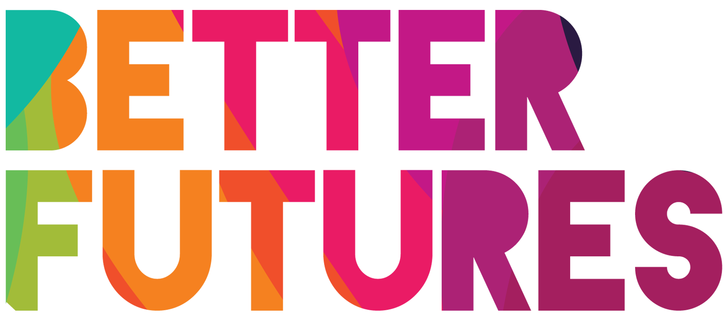 | 🌠INSPIRE ▶️ link to full series

First, watch the video 🔻  🎯 Goals of this activity: | My Activity  Plan your fashion business  ⏳ This activity will take around 2 hours for parts 1-2  & around 4 hours for parts 3-4  💬🗨️ Format: This activity can be done in different ways:  - With a mentor, coach or a friend  ⭐recommended  - On your own  - In a group: each of you do it & share & give feedback

For you to think what would excite you  about starting a fashion business  For you to identify which type of fashion business you want to build  For you to define what is your own style | For you to consider what you need to make your designs real  For you to discuss your idea with other people and ask for constructive feedback

⁉️ How to do the activity (✅ tick the checkboxes when you have completed each step)
☐ 1️⃣ Decide whether you want to do this activity on your own, with 1-1 support or in a group.  ☐ 2️⃣ Watch the video for this activity  ☐ 3️⃣ Think for a moment: What useful tips Maria shared in the video to start your own fashion business?  ☐ 4️⃣Read & think through and fill each part  of the the activity template below  ☐ 5️⃣Once you have completed parts 1 of the activity, conduct some research on other fashion businesses (you can search online like Maria advised e.g Pinterest, Instagram etc) | ☐ 6️⃣ Once you have researched and observed other fashion businesses, complete parts 2  ☐ 7️⃣ Part 3 will help you consider what equipment, material and skills you need to build your own fashion business.  ☐ 8️⃣ Conduct some research and list the best fashion design courses that will help you learn and improve your skills.  ☐ 9️⃣ Finally, work on Part 4 to discuss your fashion business with your network, other designers and potential customers. What can you learn from them?

1 What excites you about the fashion industry? 👜👛👞👙👚🧥
What excites you 🤩  about the world of fashion? | What excites me in the fashion world is…✍️
Who are your favourite designers 👔 | What are your favourite  fashion brands? | What 📈 trends have you seen  in the fashion industry?
✍️ My favourite designers are:  - ...  - ...  - …  ✍️ They inspire me because … | ✍️ My favourite brands are:  - ...  - ...  - ...  ✍️ They inspire me because … | ✍️ My favourite trends are:  - ...  - ...  - …  ✍️ They inspire me because …
Where can you learn or improve your design and technical skills? | ☐ | Take (free) online course | ☐ | Read books
 | ☐ | Get experience in a company | ☐ | Ask network/professionals
 | ☐ | Meet up with people learning the same skills through online communities | ☐ | Other:...

2 Now, decide what fashion products you will create 🖌️🖍️✂️🎨
What type of product will you create?  👗👔👜👛👠👞👙 | The product I will create is…✍️
How do you find the inspiration 🧐  for your design? | ☐ | I discuss with people who have an interest in the fashion industry | ☐ | I go window shopping
 | ☐ | I do online research (Google, Instagram, Pinterest, YouTube, etc.) | ☐ | I watch fashion shows in person / online
 | ☐ | I follow influencers on social media | ☐ | I go to exhibits, art shows, etc.)
 | ☐ | I read fashion blogs | I have other ways of finding inspiration, by…
How would you describe your style? 🖌️🖍️✂️🎨 | My style is … ✍️  Customers will find my product & style unique because…✍️
What story will you tell customers about your product & 🍿 brand? | The story of my brand is…✍️

3 How will you make your fashion business real?
Where do you make / create your designs? 🏠🏭🏢 | I make and create my design in…✍️
Let’s talk about your equipment 🧵 ✂️🧷📌
What type of ✂️ equipment  do you need to create your design?  (for example a sewing machine)  …✍️ | Where can you get your equipment?  …✍️ | How much will it cost?  …✍️
Let’s talk about your materials 🧶
What type of 🧶 material do you need  to create your product?  …✍️ | Where can you buy  your material?  …✍️ | These materials  will cost me  …✍️
Where  will you 🛍 sell  your designs? | Online 🖥 |  | In a shop 🛍
 | ☐ | My own website | ☐ | Someone else shop
 | ☐ | Instagram | ☐ | My own shop
 | ☐ | Facebook Marketplace | ☐ | Street market
 | ☐ | Big eCommerce marketplace  (for example Ebay, Etsy, Amazon, etc.) | ☐ | Other:
 | ☐ | Online fashion marketplace
Where can you learn or improve your design and technical skills? | ☐ | Take (free) online course | ☐ | Read books
 | ☐ | Get experience in a company | ☐ | Ask network/professionals
 | ☐ | Meet up with people learning the same skills through online communities | ☐ | Other:...
How will you communicate  with your customers? 📨 | Online 🖥 |  | In person 🙋‍♂️
 | ☒ | Social Media | ☐ | Word of mouth
 | ☐ | Website | ☐ | Partnership/Sponsorships
 | ☐ | Blog | ☐ | Public presentation
 | ☐ | Emails | ☐ | Ads in local magazines
 | ☒ | Newsletter | ☐ | Other: ...

4 Networking in the Fashion industry 🙋‍♂️🤝🙋‍♀️
Who 👀could  help you with your  fashion business? | The people who could help me in my fashion business are:  - …  - …  - …  - …
📅 How will you contact these people? ☎️ | I will contact them by…✍️
What feedback & ideas 💡 have you received from talking to these people? 💬 | The feedback from other designers🧑‍🎨 is:  …✍️ | The feedback from other 🛒 customers is:  ... ✍️
How can you grow  📈 your network to develop your fashion business 🎯 | To grow my network and develop my business, I will …✍️

