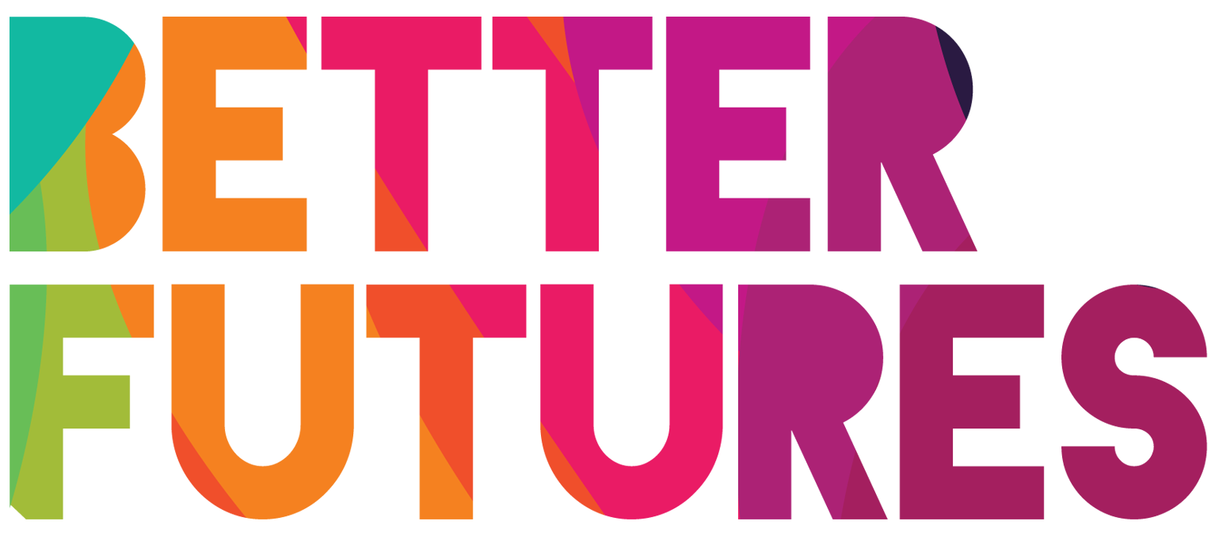 | 🏁 GET STARTED ▶️ link to full series

First, watch the video 🔻  🎯 Goals of this activity: | My Activity  My Brand & Communication Plan  ⏳ This activity will take around 1 hour for part 1  and 1 hour for part 2.  💬🗨️ Format: This activity can be done in different ways:  - With a mentor, coach or a friend  ⭐recommended  - In a group: each of you do it, share & give feedback  ⭐recommended  - On your own

To identify what makes your business stand out on its own  To think of what your competition offers against what you offer in a competitive market | To consider how to market your idea  To identify who your customers are, and how to communicate with them

⁉️ How to do the activity (✅tick the checkboxes when you have completed each step)
- 1️⃣Take the time to do this task on your own and at your own speed especially for the research related parts (2-3). It is ideal to do this with others so you can have an inclusive approach  - 2️⃣Watch the video for this activity  - 3️⃣Think for a moment: What would make my idea stand out in a competitive market considering all the things Maria mentions?  - 4️⃣Read, research and think through and fill each part of the activity template below | - 5️⃣Once you have completed parts 1 to 2 of the activity, take some time to research the answers you placed in the previous questions. Record these answers in the appropriate questions in part 3.  - 6️⃣Reflect on how the answers from part 3 and how they impact your initial answers in part 1-2  - 7️⃣Complete part 4 based on where your previous analysis leads you.

1 My Brand
Create a  Brand Mood Board on Pinterest with images that could inspire your brand | As a first step, collect photos and images that you like as inspiration  for your own brand on Pinterest pinterest.com, a popular picture gallery platform.  You can other brands, or simply photos and illustrations  that you think of when you imagine your brand.  These might be things such as art, objectives,  or something from nature that you find inspiring.  Once you have made a board with inspiring photos &  illustrations, paste the link to it here: [enter link to your bord here]  You can show the board to a brand designer to inspire their work on your brand.
The brand name of my business will be: | [REPLACE THIS TEXT WITH YOUR BRAND NAME]
My slogan  (6 words that always go under your brand name and that explain what your business does) | [replace these 6 words with slogan]
I want these  🎨colours  to be featured  in my business brand: | Use the free tools on coolors.co/ to generate colours. On ‘Coolors’, you can get the unique digital codes for the colours you choose – these codes are called a “HEX CODE”.  Colour 1 Colour 2 Colour 3  [✍️ Enter colour name] [✍️ Enter colour name] [✍️ Enter colour name]  Hex Code: Hex Code: Hex Code:  This colour represents the following emotion …✍️ This colour represents the following emotion …✍️ This colour represents the following emotion …✍️
In my 💫logo,
I want to see:
🖌️I will get my brand made… | …by a friend  …by a professional brand designer – you can find such professionals here  … I will do it myself!

2Communicating with my customers
Who are  your customers:  🧑🏾 👩🏼‍🦰 🧕🏽 🧔🏼 👶🏻👧🏾👳🏻 | …✍️
On what channels / in what places  do you plan to communicate  with these customers? | ☐ Google search ☐ Local Phone Book ☐ Google Maps ☐ Local Phone Book  ☐ Online marketplaces ☐ Real life marketplaces ☐ Online directories  ☐ Instagram ☐ Facebook Marketplace ☐ Twitter  ☐ Tik Tok ☐ YouTube ☐ Print magazines  ☐ Online magazines ☐ Newspaper ☐ Radio  Other:
What  🖨️🖼️ marketing materials  will you create  to communicate  on these channels? | ☐ Social media posts ☐ Social media videos ☐ YouTube videos ☐ Local Phone Book  ☐ Online flyers (PDF) ☐ Print flyers ☐ Advertisements  ☐ Blog posts ☐ Feature in news articles ☐ Radio show appearance  Other: …✍️
What 📖 story  will you tell  your customers  in your marketing materials: | What marketing materials  …✍️ communicate on these channels?

