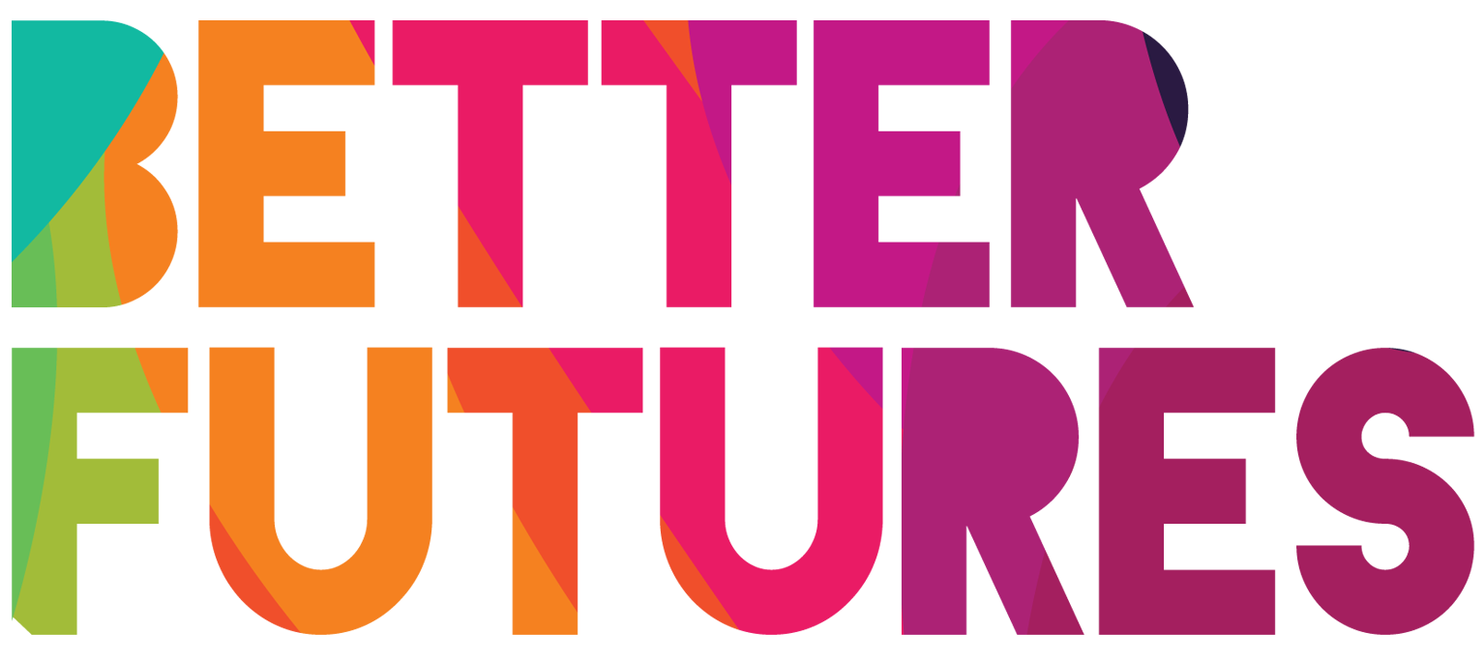 | 🏁 GET STARTED ▶️ link to full series

First, watch the video 🔻  🎯 Goals of this activity: | My Activity  My Customer Segments  ⏳ This activity will take around 2 hours for parts 1-2  & 3 hours for part 3.  💬🗨️ Format: This activity can be done in different ways:  - With a mentor, coach or a friend ⭐recommended  - On your own  - In a group: each of you do it & share & give feedback

To think as a customer  To define and know your  customer segment  - To understand your  customer’s expectations | To identify the current  and future customer trends  To interact with experts and customers  so that you can take action and improve  your product/service accordingly

⁉️ How to do the activity (✅tick the checkboxes when you have completed each step)
☐ 1️⃣ Decide whether you want  to do this activity on your own,  with 1-1 support or in a group.  ☐ 2️⃣ Watch the video for this activity.  ☐ 3️⃣ Think for a moment: What useful tips Nejat shared in the video to help you understand and target your customers?  ☐ 4️⃣ Read, research and think through and fill each part of the activity template.  ☐ 5️⃣ Part 1 will make you realise  that we are all customers.  Compare your experience as a customer with your own product or service. | ☐ 6️⃣ You will identify your customer segment  in part 2. You will also know more about  them by creating your ideal customer.  ☐ 7️⃣ Complete part 3 to reflect on  your customer trends. You will compare your product/service to your competitors and identify  what are the best practices. Go around your city  and find out what are the new trends in your industry.  ☐ 8️⃣ It is now time to interact with experts and potential customers. In part 4, take the time to discuss with them and look for constructive feedback and information that you can apply to your own business.

1 We are all consumers, we are all customers 🛍️
What was your last  important 🛒 purchase?  (product or service) | My last big purchase was…✍️
🤔 What motivated  you to buy this? | I bought this item because…✍️
What do you 🤩 value  the most in this purchase? | Select more than one if needed:  ☐ Price / value for money  ☐ Quality  ☐ Convenience  ☐ Customer service | ☐ Speed  ☐ Brand  ☐ Innovation  ☐ Story  Other: ...✍️
What did you  like 👍 and dislike👎 ?  (e.g. information, payment,  delivery, sales person, etc.) | What I like when I purchase this item is…✍️  What I didn’t like when I purchase this item is…✍️
How was the  customer service? 🙋‍♀️ | The customer service was ...✍️
 | ☐ Excellent  ☐ Good | ☐ Average  ☐ Bad
 | Describe the customer service you received …✍️
Would you buy from  this company again? 🏷️ | ☐ YES, because…✍️  ☐ NO, because…✍️

2 Know your customers 🙋‍♀️ 🙋‍♂️
First, describe the product  or service you want to sell 🏬 | The product, or service, that I want to sell is...✍️
What type of customer would be interested in your product/service? 🔎 💆
Personal information 🏷 | They would buy my product / service 🤷 because… | How does your product / service  help your customers? 💡
Age: ...  Place where they live: ...  Occupation: ...  Hobby: ...  Economic situation: ...  Background...  Other: ... | They would buy it because …✍️ | What they would find the …✍️
How will you 🙋‍♂️reach out to  meet and 💬 discuss with your customers? | To reach, meet and discuss with customers about my product/service,  I will…✍️

3 🤝Meet potential customers to get new ideas 💡
How will you  contact customers 🗣️  to collect more information  about their needs and expectations? | I will contact customers by…
What ⁉️questions  are you going to ask  these customers? | Question 1: | ✍️
 | Question 2: | ✍️
 | Question 3: | ✍️
 | Question 4: | ✍️
How will you  collect feedback 📃  from customers  about your business idea? | To collect my feedback, I will:...✍️  ☐ Share online surveys  ☐ Share print surveys  ☐ Do interview (online or in person)  ☐ Organise a group discussion (online or in person)  Something else – describe here:
Who are  is an expert  who knows a lot  about customers  in your industry? | The expert in my industry is…✍️  I will reach out to this expert by...✍️
Go to your local  📚 business library  and ask for information about the customer trends in your industry. | What I learned from my local business library is...✍️
After doing all this research,  in summary, what have you learned  about your customers? 🧐 | What I learned is that customers...✍️

